**How to prepare an extended abstract for PPPS 2025**

Presenting Authora, Second Authorb, Third Authorc

aAffiliation 1, presenting.author@somewhere.se

bAffiliation 2, second.author@somewhere.se

cAffiliation 3, third.author@somewhere.se

The abstract should be written in English. Including figures and references the abstract must not exceed two pages. The font, page and margin sizes provided by this template must not be altered. E-mail address is only mandatory for the presenting author. When including figures (Fig. 1), please bear in mind the file size limit of 5 MB. References should be added according to the following examples for journal papers [1] and book [2].

Authors should submit their abstract electronically, using the e-mail address: **ppps2025@miun.se**. Abstracts received after the deadline of March 2, 2025, may not be included in the proceedings, although the organizers reserve the right to consider late submissions at their discretion.

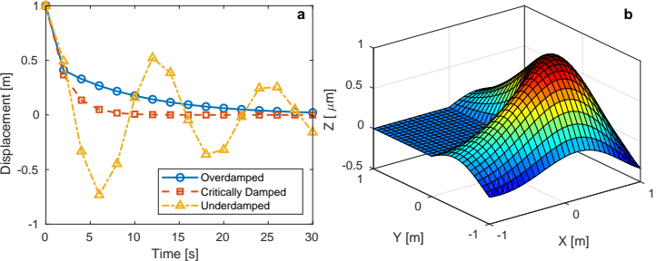Figure 1: Dummy plots for the template. (a) Oscillation of damped harmonic oscillators. (b) 3D surface plot of a vibrating membrane.

**References**

[1] O. L. Forgacs and S. G. Mason. Particle motions in sheared suspensions. IX. Spin and deformation of threadlike particles. *J. Colloid Sci.*, 14:457-472, 1959.

[2] D. J. Tritton. *Physical fluid mechanics*. Clarendon Press, second edition, 1988. pp. 21-34.