Doctoral Students:
1 Login
You log into Ladok for student to find your individual study plan. If you cannot find your individual study plan in Ladok for students, contact your faculty administrator.
2 Individual study plan
In the right menu, there is the option Individual study plan. Clicking there will bring up your ISP. At the top of the study plan there is a drop-down list with the different content tabs in the study plan.
Doctoral student and supervisor update the current version of ISP. It is possible to save the data and work on it later
Once a year, Doctoral students are asked to approve the current ISP version which is then forwarded to the main supervisor for review.

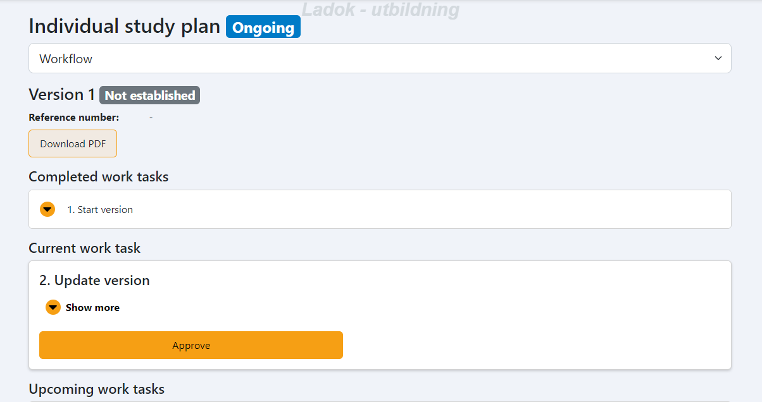

Tab - Workflow
Here you can see completed work tasks, current work tasks and upcoming work tasks, as well as which role has done/will do what.
Here are also the established versions that can be opened as a PDF file. It is also possible to open a PDF file of the current study plan. That button is located above completed work tasks.
At the bottom there is also a description of all work tasks in the flow.

Tab – Basic information
Here you can find information about your doctoral admission, general study plan, Milestones in third-cycle studies, study activity and funding as well as other documentation.
What you as a doctoral student can fill in under this tab are Milestones in third-cycle studies and other documentation.
Under other documentation will be your last ISP from the old research database (if you had an ISP in that system). Other documentation can also be added here. You can add files yourself here as well. ATTENTION! Only PDF files can be added here.

Tab - Supervisor and decision-maker
Here are the supervisors and decision makers who are connected to your studies. Here you can write notes for each role, for example the supervisor's note, the subject/department's note and the faculty's note.

Tab – Supervisor conversation
Here you can document various conversations between doctoral student and supervisor, for example follow-up of ISP.

Tab – Thesis work
The summary of the thesis work is documented here. During planning and follow-up, you must enter your milestones.

Tab - Courses and conferences
All courses in your doctoral studies that have been entered into Ladok end up here, including credits. The courses will end up as unsorted certified results and you must then sort them under either mandatory courses or elective courses, possibly together with your supervisor.
You enter planned courses yourself here.
Under non-credit-bearing activities, you enter your conferences without points, seminars without points and projects (goes as optional text).

Tab – Learning outcomes
This is a new function in the individual study plan at Mid Sweden University. The faculties are working on procedures for how it should be used.
If you, as a doctoral student, together with your supervisor, want to add information to learning outcomes, you can do so.

Tab – Timeplan
Here, the activities that are in the study plan per half year are shown. For example, study activity and funding, courses, credits, etc.

You enter your publications into the DiVA system. They will not appear in the study plan. If they need to be added to the study plan at some point, they must be taken out separately from DiVA.

