Supervisors/Head of Department/Head of Subject/ISP Administrator:
1 Login
You log into Ladok for staff to find your doctoral students' individual study plans.
On the start page there is another tab called My doctoral students (ISP). There, you as the main supervisor, supervisor and reviewer for the subject/department will be able to see the doctoral students you are connected to.

2 Individual study plan
In the left menu there are different tabs.
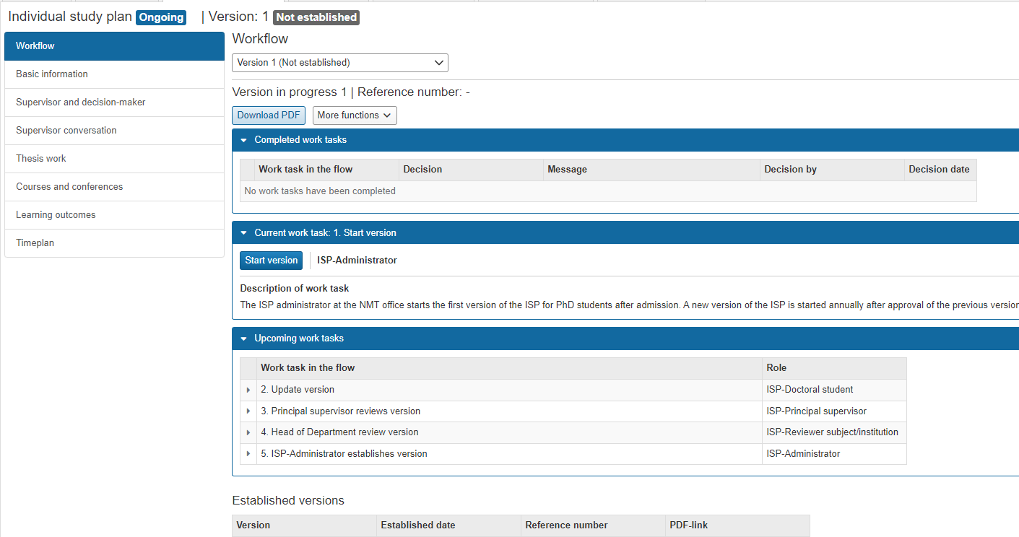

Tab - Workflow
Here you can see completed work tasks, current work tasks and upcoming work tasks, as well as which role has done/will do what.
Here are also the established versions that can be opened as a PDF file. It is also possible to open a PDF file of the current study plan. That button is located above completed work tasks.
At the bottom there is also a description of all work tasks in the flow.

Tab – Basic information
Here you can find information about the doctoral student's admission, the general study plan, milestones in the doctoral education, study activity and funding as well as other documentation.
Under other documentation, the doctoral student's last ISP from the old research database will be located. Here you can also add other documentation that the doctoral student has. The doctoral student can add files here as well.
ATTENTION! Only PDF files can be added here.

Tab - Supervisor and decision-maker
Here are the supervisors and decision makers who are connected to the doctoral student's studies. Here you can write notes for each role, for example the supervisor's note, the subject/department's note and the faculty's note.

Tab – Supervisor conversation
Here you can document various conversations between doctoral student and supervisor, for example follow-up of ISP.

Tab – Thesis work
The summary of the thesis work is documented here. During planning and follow-up, the milestones are entered.

Tab - Courses and conferences
All courses in the doctoral student's studies entered in Ladok end up here, including credits. The courses will end up as unsorted certified results and the doctoral student must then sort them under either mandatory courses or elective courses, possibly together with their supervisor.
Planned courses are entered by the doctoral student himself here.
During non-credit-bearing activities, the doctoral student enters conferences without points, seminars without points and projects (goes as optional text).

Tab – Learning outcomes
This is a new function in the individual study plan at Mid Sweden University. The faculties are working on procedures for how it should be used.
The doctoral student can, together with his supervisor, add information to learning outcomes if he wishes.

Tab – Timeplan
Here, the activities that are in the study plan per half year are shown. For example, study activity and funding, courses, credits, etc.

The doctoral student's publications are entered into the DiVA system. They will not appear in the study plan. If they need to be added to the study plan at some point, they must be taken out separately from DiVA.

